***ENTERPRISE NETWORKING PROJECT***

***IP TELEPHONY (VOIP) AND DIAL –PEERING NETWORKING PROJECT***

**Course Name:**

Computer Networks

**Submitted To:**

Miss Rukhma Riaz

**Group Members:**

Aaimlik Abbasi I212540

Huma Ejaz I210839

Muhammad Hammad I212586

Muhammad Aqib I170260

**Premise:**

Turtle Consultancy Limited specializes in delivering IP infrastructure solutions to medium sized organizations worldwide, with the expansion of the company, a newly acquired branch needs network, your manager is faced with demands of business and plethora of technology challenges.

**Requirements:**

|  |  |  |  |
| --- | --- | --- | --- |
| **Department** | **Phones** | **PCs** | **Printers** |
| **Finance** | **10** | **10** | **1** |
| **HR** | **10** | **10** | **1** |
| **Sales** | **10** | **10** | **1** |
| **ICT** | **10** | **10** | **1** |

PCs are connected to phones instead of switches, the network has four servers in the server area and configured servers are shared between all the users which are

* EMAIL
* DNS
* DHCP
* HTTP

The IT manager emphasizes scalability and availability and hence you are required to provide a complete network infrastructure design and implementation.Following IP address will be used

For Data: 192.168.100.0/24

For Voice 172.16.100.0/24

Between Routers: 10.10.10.0/24

**Explanation of each component:**

1. **ROUTER :-** each department is to have a VOIP enabled router with server-side LAN attached to the ICT department router .note use cisco 2811 router.
2. **SWITCHES:-** each department has an access layer switch note cisco 2960 switch.
3. **Connections:-**use serial connection between the router and a router than a straight cable between the router to switch ,switch to hosts ,phones to pcs.
4. **SUBNETS:-** each department will be accessing two subnetworks ,for example data and voice subnets ,carry out appropriate subnetting.
5. **Basic setting:-** configure basic device settings such as host names ,console password enable password and banner messages encrypt all passwords and disable IP domain lookup.
6. **DHCP Server :-** for voice (voIP) use the representative router as DHCP server while for the data use the DHCP server device at the server side site.
7. **VLANS :-**Each department will be in two VLANS. One for the data and another for voice. All IP phones in the network should be in VLANS 100.
8. **INTER -VLAN Routing:-** use OSPF as routing protocol to advertise routers on the routers.
9. **IP addressing:-** all devices in the network are expected to obtain an ip address dynamically from the respective DHCP servers while the devices in the server room are to be allocated IP addressing statically.
10. **Routing protocols :-** Use OSpf as routing protocol to advertise routes on the routers.
11. **Remote access:-** configure SSH in all the routers for remote login.
12. **TELEPHONY SERVICES:-** configure VOIP on the routers for remote login and dial numbers in this format for departments,finance (1..),HR(2..),Sales(3..) and ICT(4.._ where 1.. Can be 101 to 199) and so on.
13. **Routing for VoIp :-**configure dial-peering on the routers to allow IP phones from the different routers to communicate
14. **Finance:-**Test communication ,ensure everything configured is as working as expected

**Topology:**

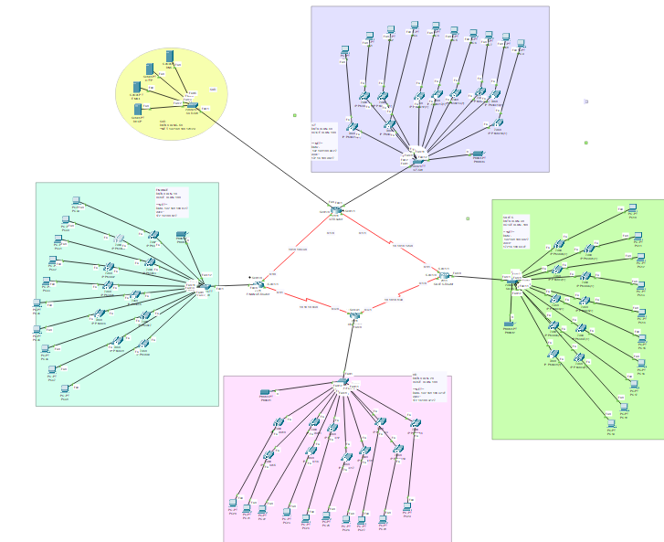

**Configuration Steps :-**

1. Network design and beautifications.
2. Basic setting to all the devices plus ssh on the router
3. VLANS assignment plus all access and truck ports on the switches.
4. Subnetting and IP addressing
5. Static IP address to server room devices
6. DHCP server service devices configuration
7. Configure DHCP for voice
8. Inter Vlan routing on routers plus ip dhcp helper addresses
9. OSPF on the routers
10. Configure VOIP configuration in all routers
11. Dial peering configuration in all router
12. Verifying and testing configuration

Following configuration script sets up basic security measures such as password protection for console access, a warning banner, and encryption for stored passwords

1. en
2. conf t
3. hostname ICT-Router
4. enable password cisco
5. line console 0
6. password cisco
7. login
8. exit
9. banner motd #NO UNAUTHORIZED ACCESS,THIS IS PUNISHABLE BY LAW!!#
10. service password-encryption
11. no ip domain lookup // disable the DNS feature on the device
12. do wr

**To add devices on ssh router:-**

To add devices to the ssh we follow the following commands:

1. username cisco password cisco
2. ip domain name cisco.net
3. crypto key generate rsa general-keys modulus 1024
4. ip ssh version 2
5. line vty 0 15
6. login local
7. transport input ssh
8. exit
9. do wr

**FIN_SW**

1.We are setting username and password for the authentication.

2.Define domain name for the device

3.Generate RSA key for ssh

4.specify ssh version 2 for security

5. Configure vty lines for ssh access and enable local login authentication

6.allow ssh as transport input for Vty lines

7.save the configuration changes

Follow the above instruction for all the four routers

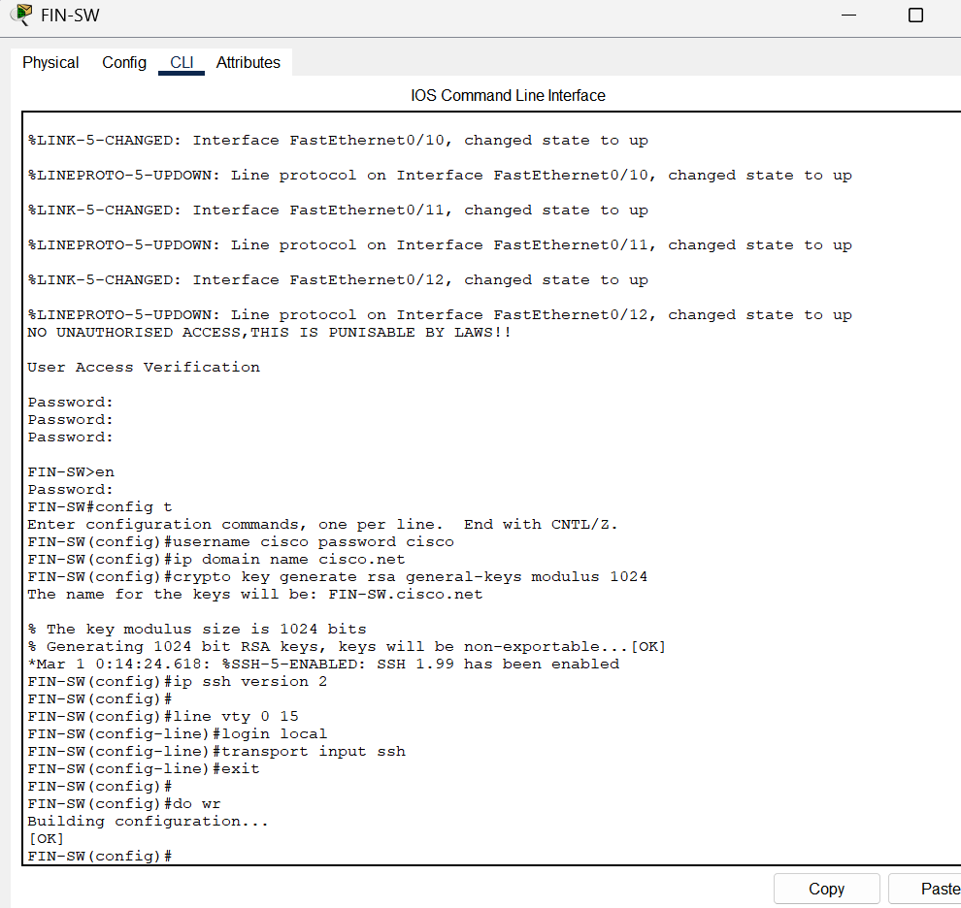

The router after applying the commands gives the response Building Configuration..

And then [OK]

**Subnetting and IP Addressing:**

1. int fa0/1
2. switchport mode trunk
3. exit
4. int range fa0/2-24
5. switchport mode access
6. switchport access vlan 40
7. switchport voice vlan 100
8. do wr

These commands configure interface fa0/1 as a trunk port and interfaces fa0/2 through fa0/24 as access ports, assigning them to VLAN 40 for data traffic and VLAN 100 for voice traffic.

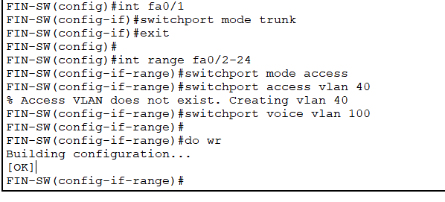

Lets show the dependence between the device and operating system

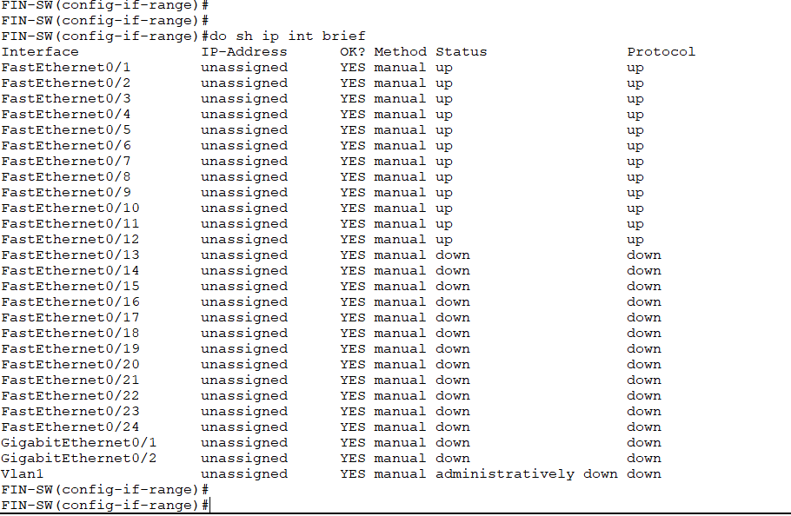

It displays the entire startup configuration file

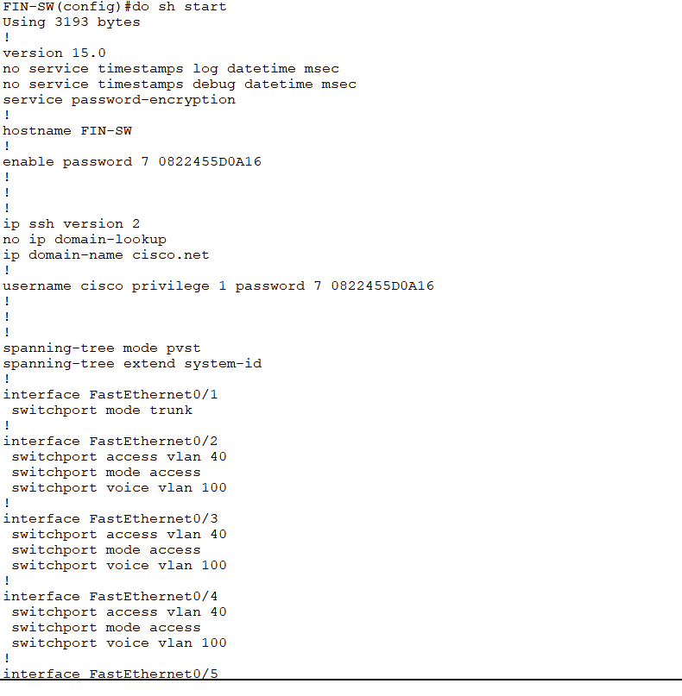

**FINANCE ROUTER IP ADDRESSING :**

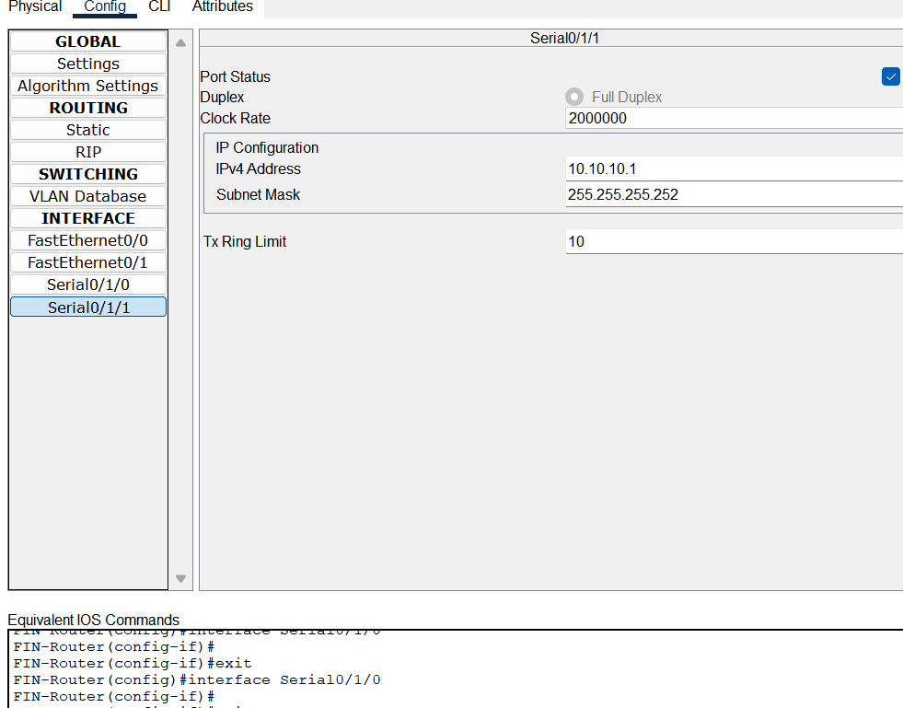

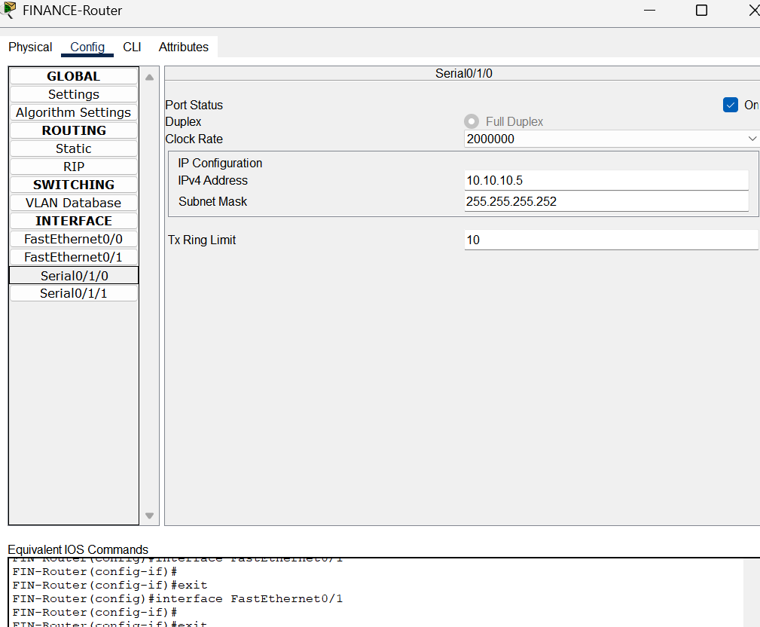

**HR ROUTER IP ADDRESSING:**

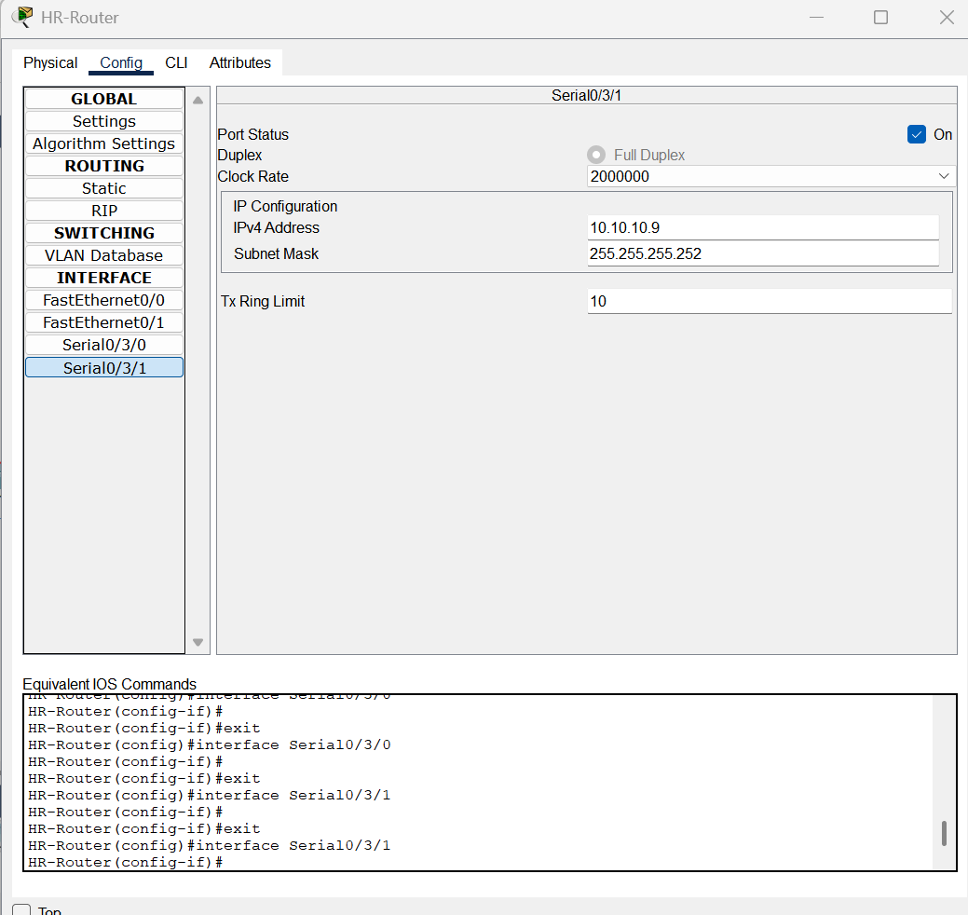

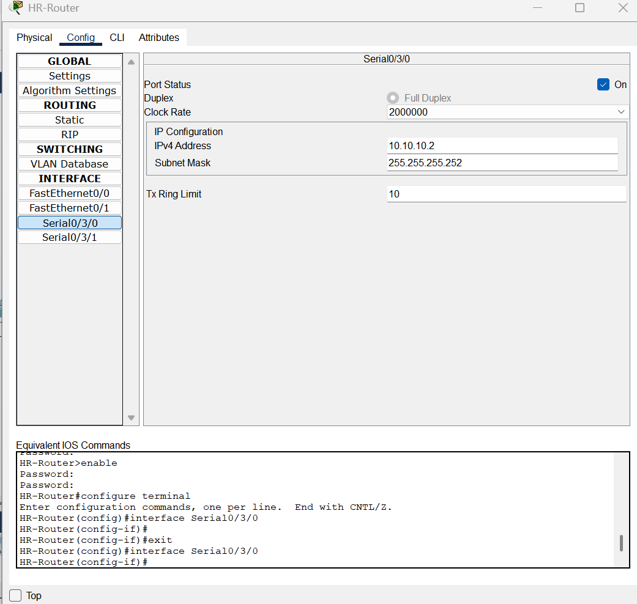

**SALES ROUTER IP ADDRESSING:**

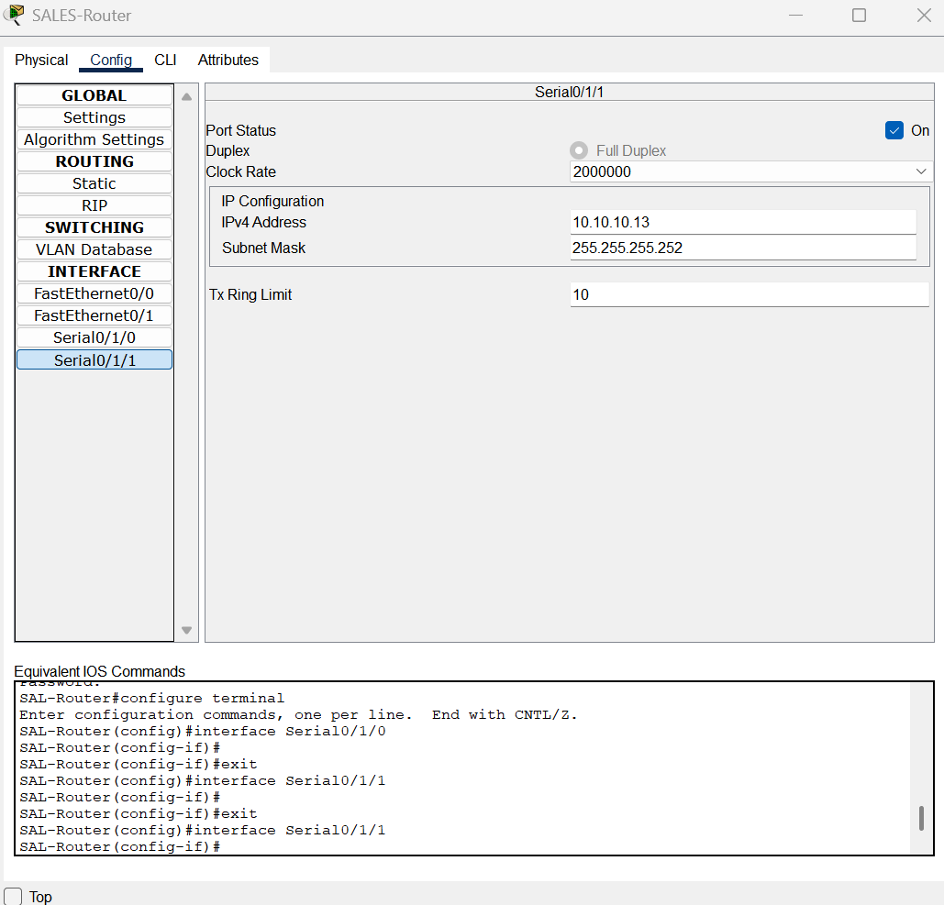

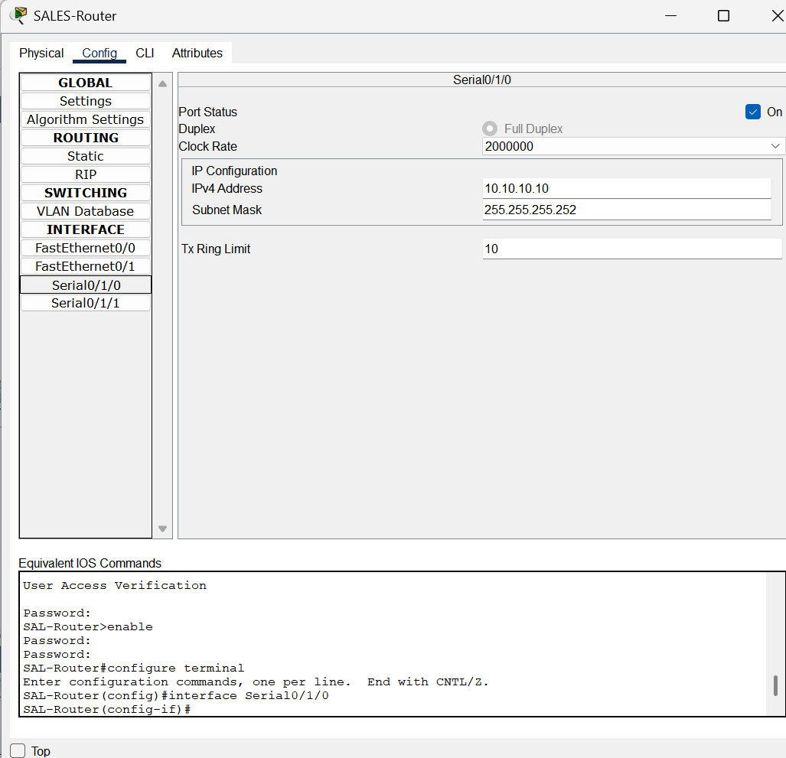

**ICT ROUTER IP ADDRESSING:**

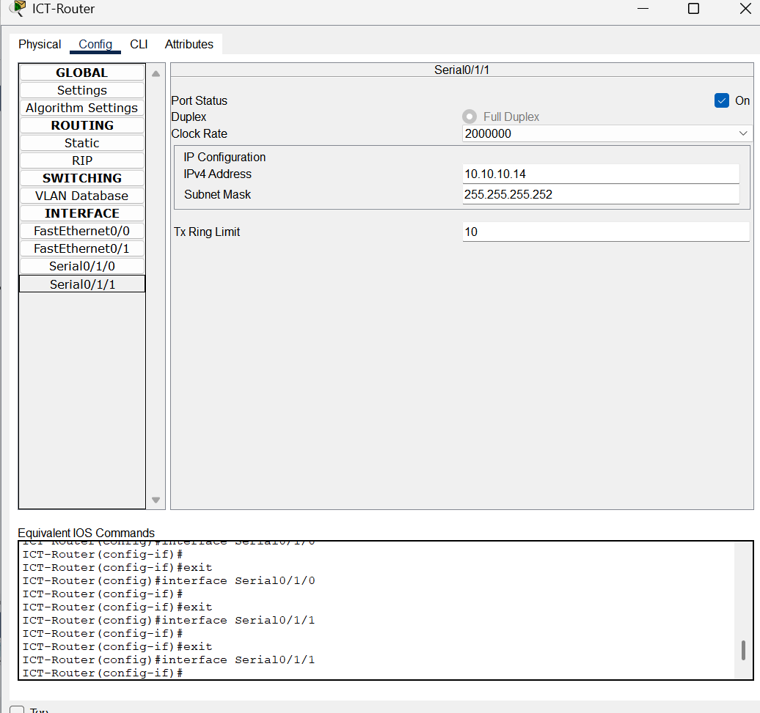

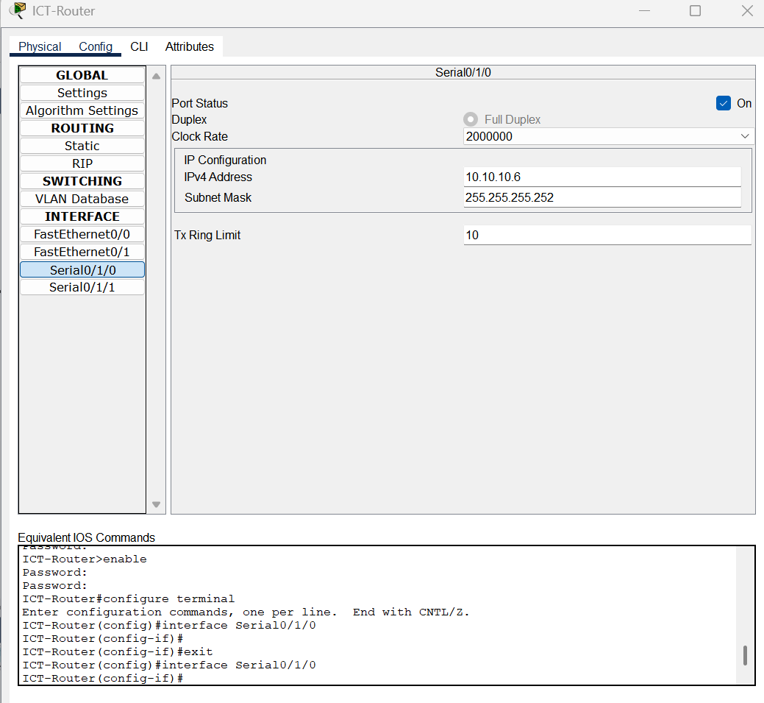

**SERVER CONFIGURATION:**

**DNS SERVER:**

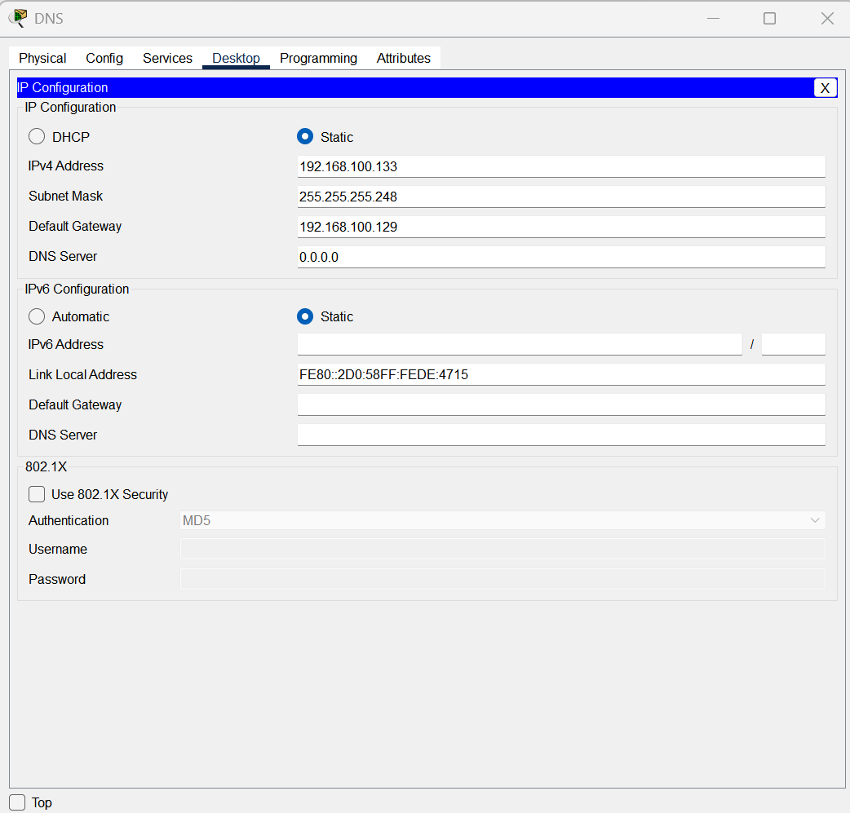

**HTTP:**

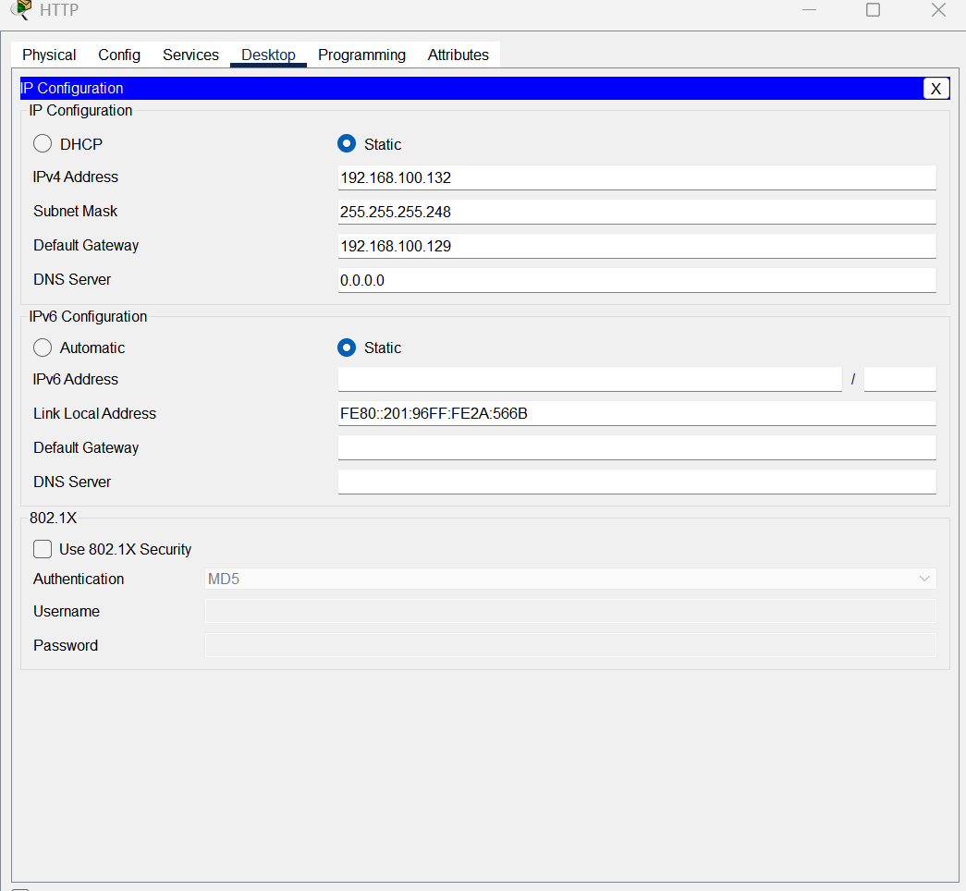

**EMAIL:**

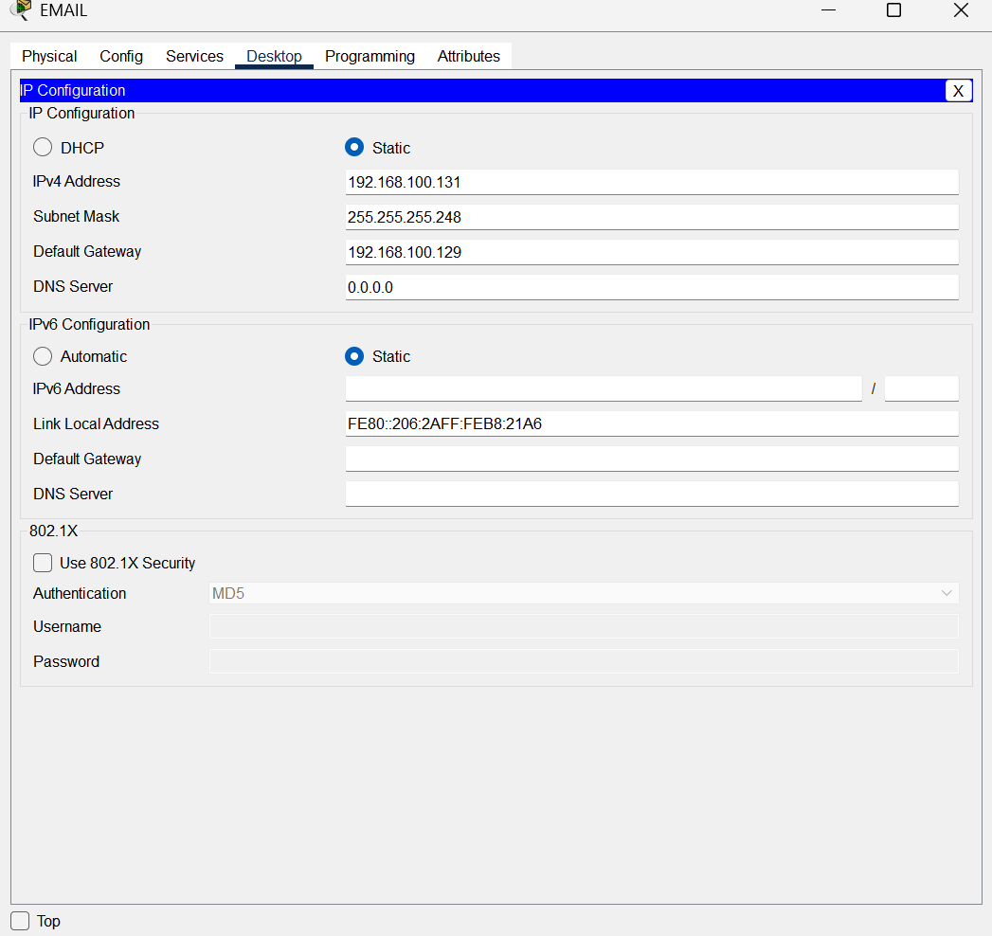

**DHCP**

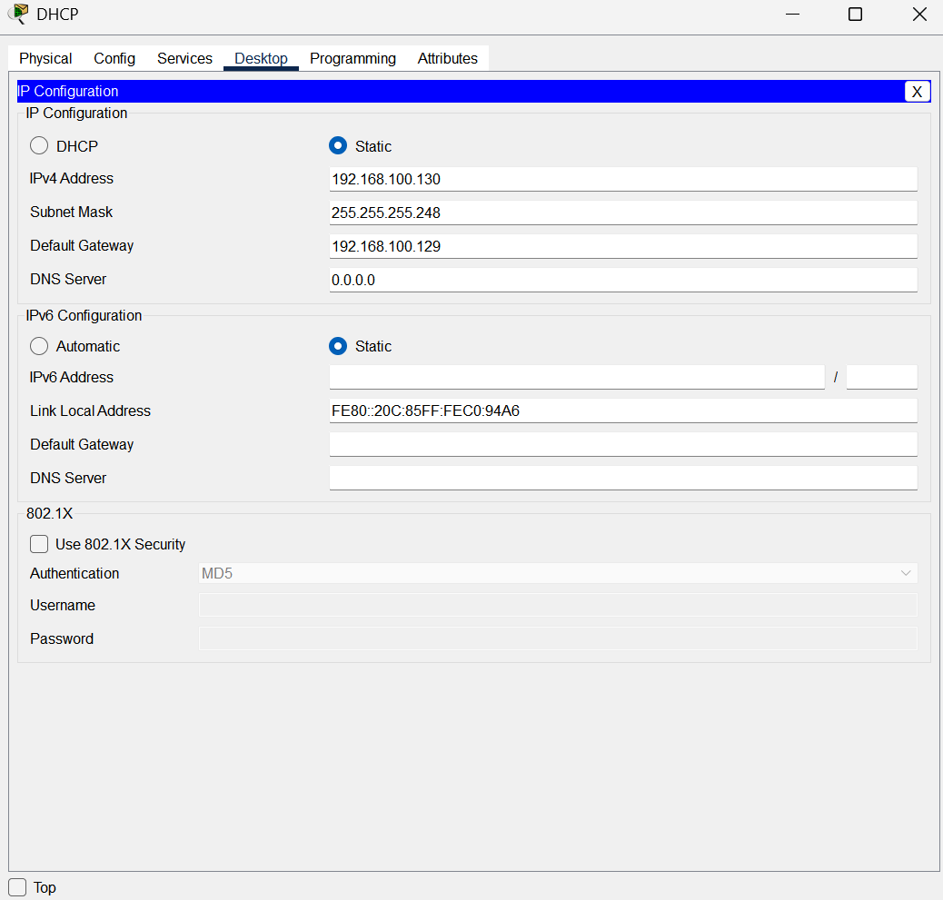

**DHCP SERVER CONFIGURATION:**

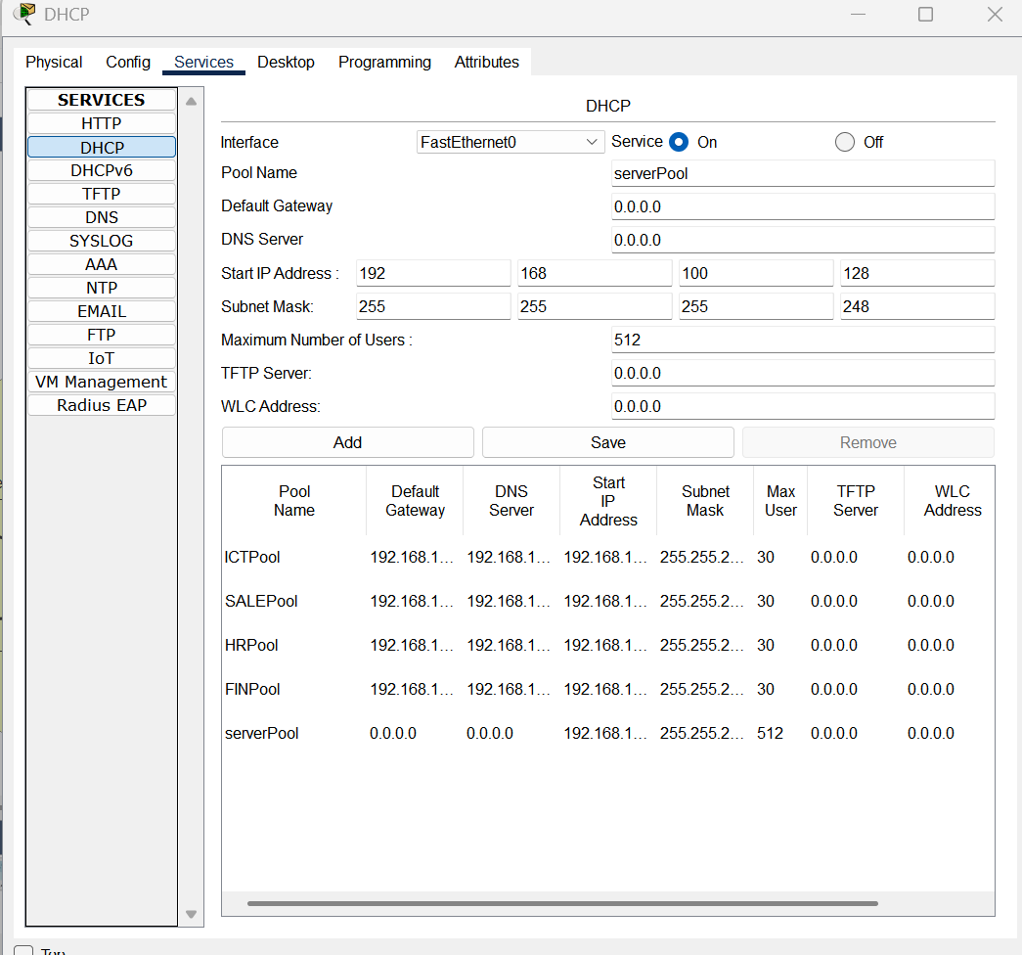

**IPS:**

**Between the Routers**

|  |  |
| --- | --- |
| **Routers** | **Network Address** |
| **Finance to HR** | **10.10.10.0/30** |
| **Finance to ICT** | **10.10.10.4/30** |
| **Sales to HR** | **10.10.10.8/30** |
| **Sales to ICT** | **10.10.10.12/30** |

**Phones IP:**

**Base Network: 172.6.100.0**

|  |  |  |  |  |  |
| --- | --- | --- | --- | --- | --- |
| Department | Network Address | Phones | Subnet Masks | Host Address Range | Broadcast Address |
| Finance | 172.6.100.0 | 20 | 255.255.255.224/27 | 172.6.100.1-30 | 172.6.100.31 |
| HR | 172.6.100.32 | 20 | 255.255.255.224/27 | 172.6.100.32-62 | 172.6.100.63 |
| Sales | 172.6.100.64 | 20 | 255.255.255.224/27 | 172.6.100.65-94 | 172.6.100.95 |
| ICT | 172.6.100.96 | 20 | 255.255.255.224/27 | 172.6.100.97-126 | 172.6.100.127 |

IP Addressing:

PC and Printers:

Base Network:192.168.100.0

|  |  |  |  |  |  |
| --- | --- | --- | --- | --- | --- |
| Department | Network Address | Devices | Subnet Masks | Host Address Range | Broadcast Address |
| Finance | 192.168.100.0 | 21 | 255.255.255.224/27 | 192.168.100.1-30 | 192.168.100.31 |
| HR | 192.168.100.32 | 21 | 255.255.255.224/27 | 192.168.100.33-62 | 192.168.100.63 |
| Sales | 192.168.100.64 | 21 | 255.255.255.224/27 | 192.168.100.65-94 | 192.168.100.95 |
| ICT | 192.168.100.96 | 21 | 255.255.255.224/27 | 192.168.100.97-126 | 192.168.100.127 |
| Servers | 192.168.100.128 | 4 | 255.255.255.248/29 | 192.168.100.129-134 | 192.168.100.135 |

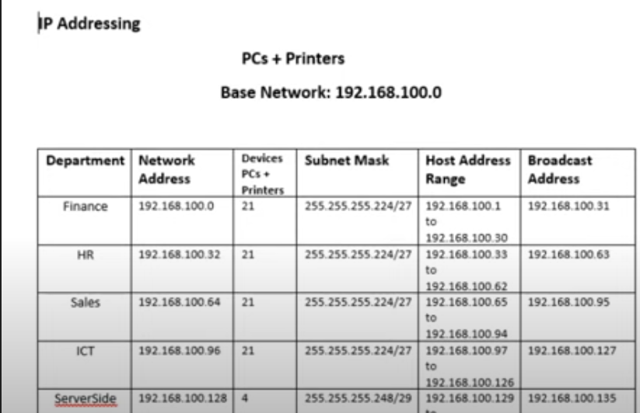

**DHCP:**

Commands:

We exclude an ip from the dhcp pool and add the specific and add the specific part to the pool for example ICTVOICE

Then we set the network and the default router with options for the IPs.

1. ip dhcp excluded-address 172.16.100.97
2. ip dhcp pool ICTVOICE
3. network 172.16.100.96 255.255.255.224
4. default-router 172.16.100.97
5. option 150 ip 172.16.100.97
6. exit
7. do wr

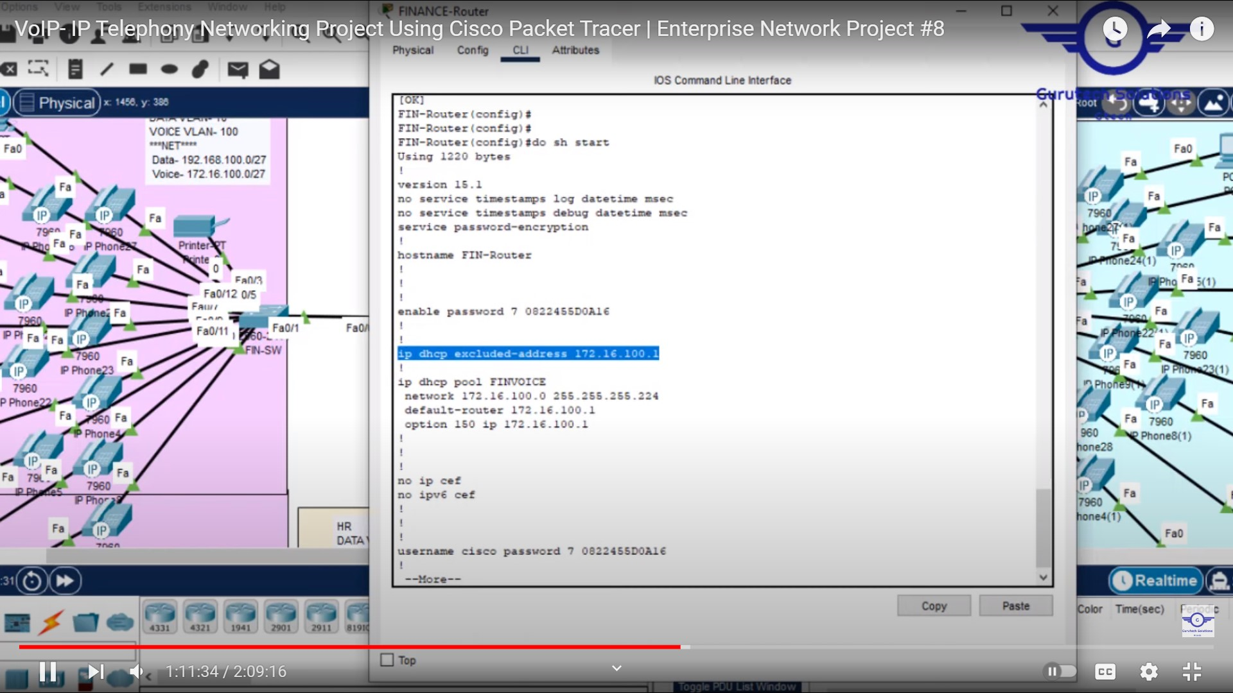

**Configuring DHCP for Voice:**

1. int fa0/1.50
2. encapsulation dot1q 50
3. ip add 192.168.100.129 255.255.255.248
4. exit

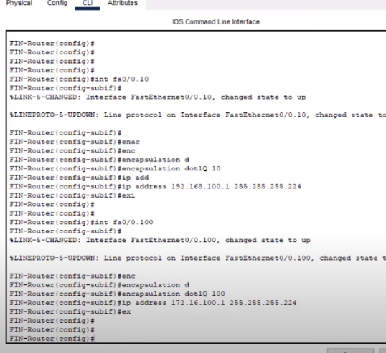

**OSPF on the Router:**

1. router ospf 10
2. network 10.10.10.8 0.0.0.3 area 0
3. network 10.10.10.12 0.0.0.3 area 0
4. network 192.168.100.64 0.0.0.31 area 0
5. network 172.16.100.64 0.0.0.31 area 0

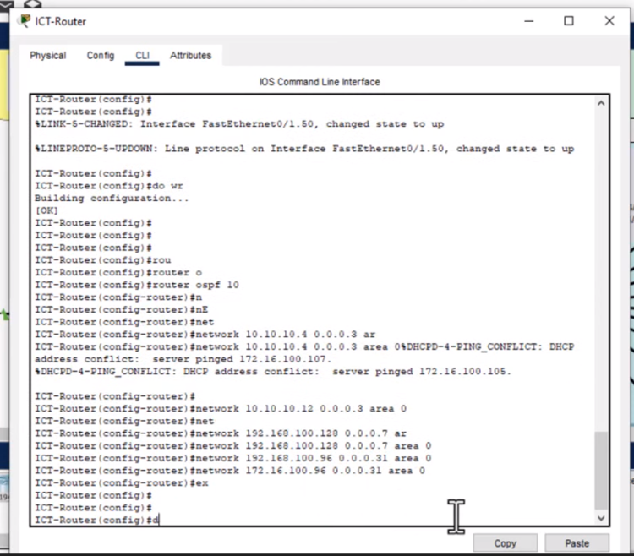

**Configure VoIP configuration in all routers:**

1. telephony-service
2. max-dn 20
3. max-ephones 20
4. ip source-address 172.16.100.97 port 2000
5. auto assign 1 to 20
6. exit
7. ephone-dn 1
8. number 401
9. ephone-dn 2
10. number 402
11. ephone-dn 3
12. number 403
13. ephone-dn 4
14. number 404
15. ephone-dn 5
16. number 405
17. ephone-dn 6
18. number 406
19. ephone-dn 7
20. number 407
21. ephone-dn 8
22. number 408
23. ephone-dn 9
24. number 409
25. ephone-dn 10
26. number 410

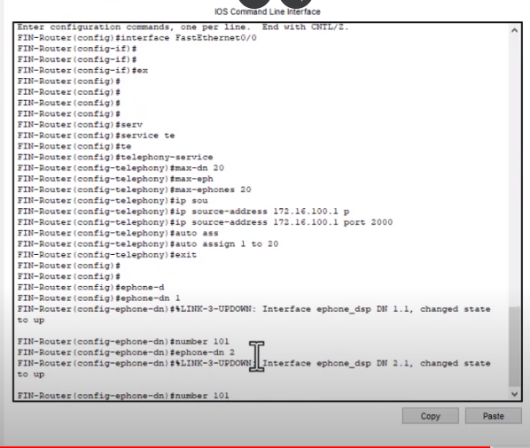

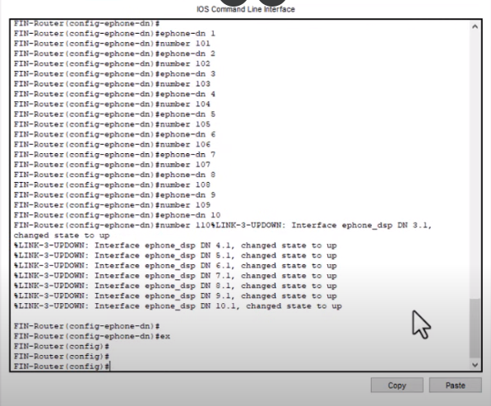

VOIP Calls:

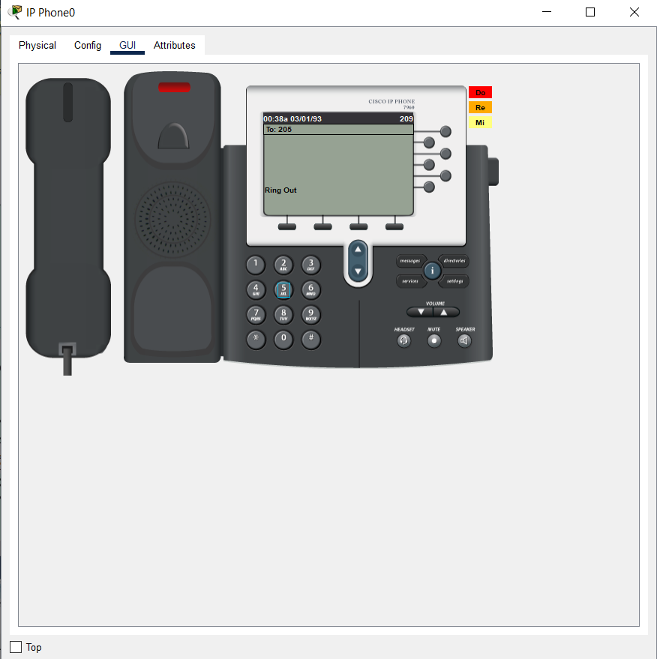

**Dial Peering Configuration in all Routers:**

dial-peer voice 3 voip

destination-pattern 1..

session target ipv4:10.10.10.1

exit

dial-peer voice 4 voip

destination-pattern 2..

session target ipv4:10.10.10.9

exit

dial-peer voice 5 voip

destination-pattern 4..

session target ipv4:10.10.10.14

Exit

do wr

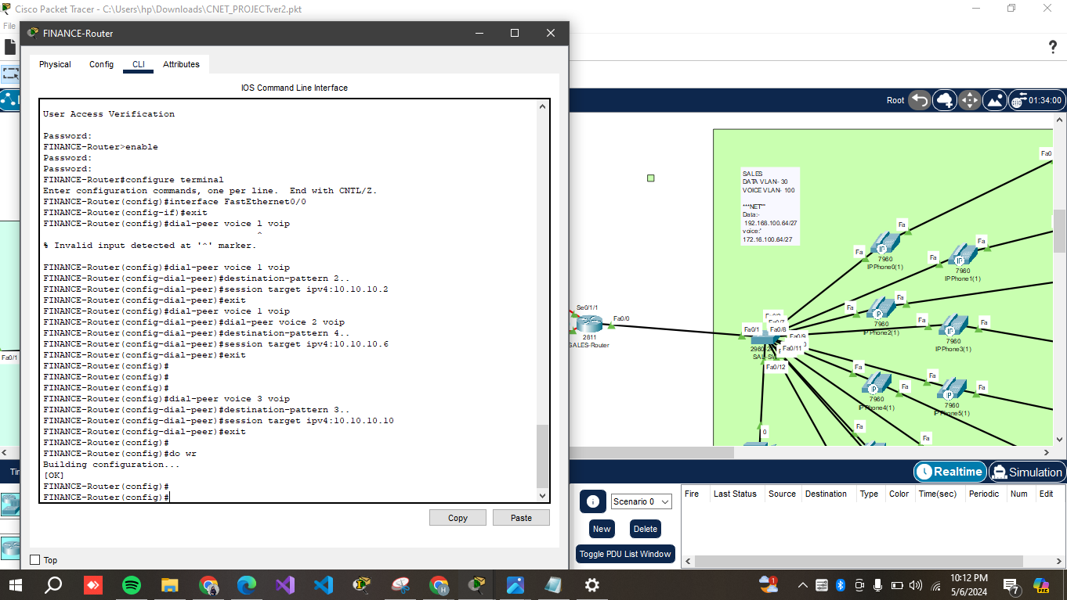

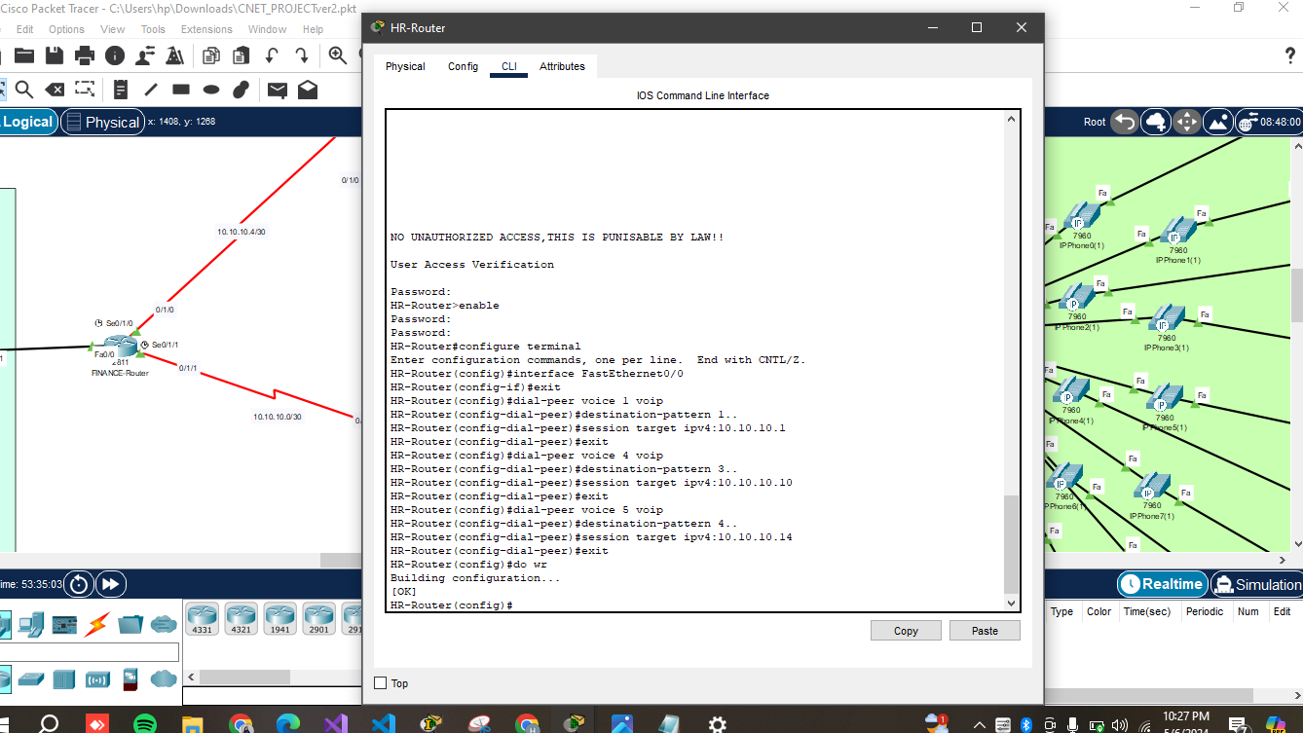

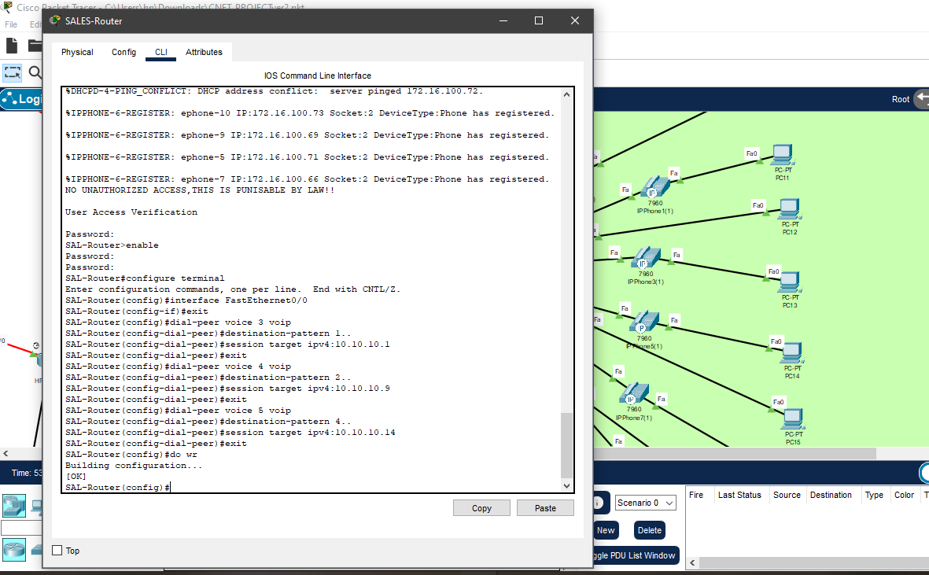

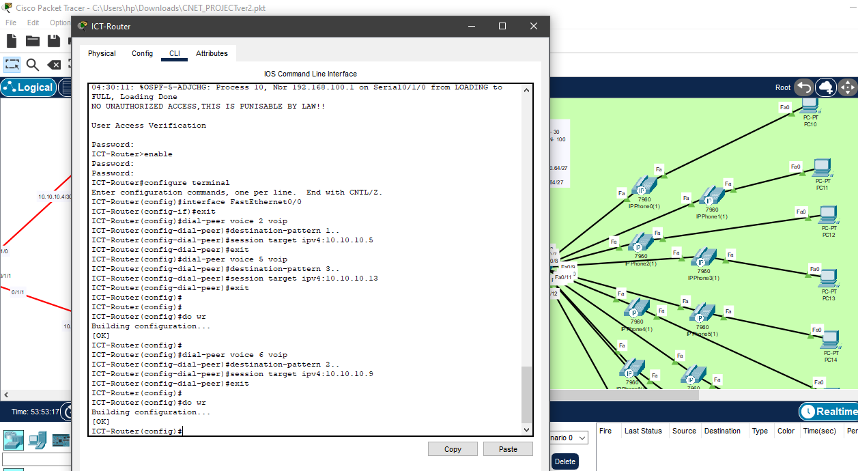

**Verifying and testing configuration:**

Verifying on the same network,

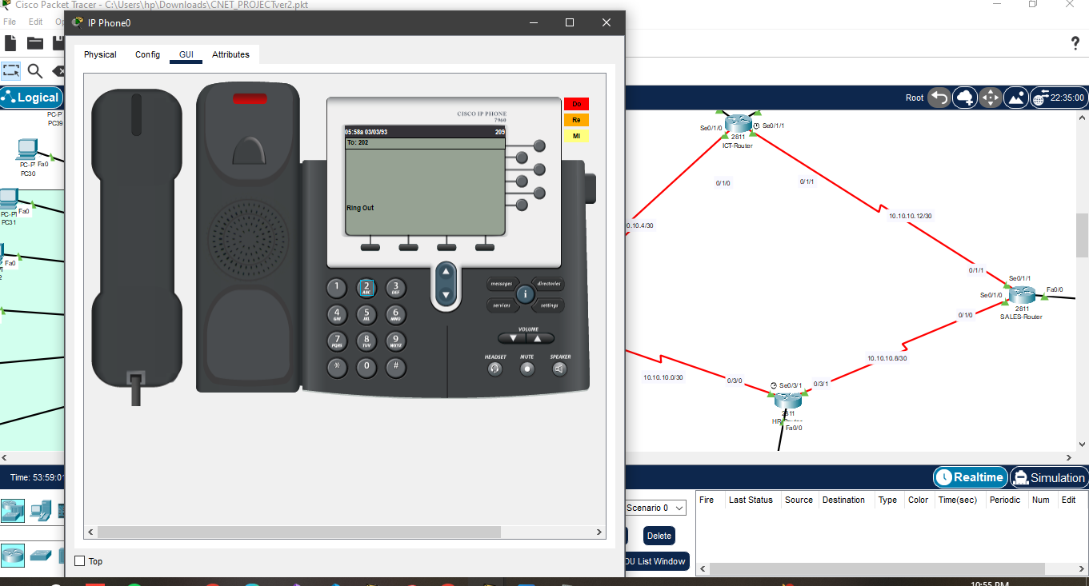

Verifying on different network,

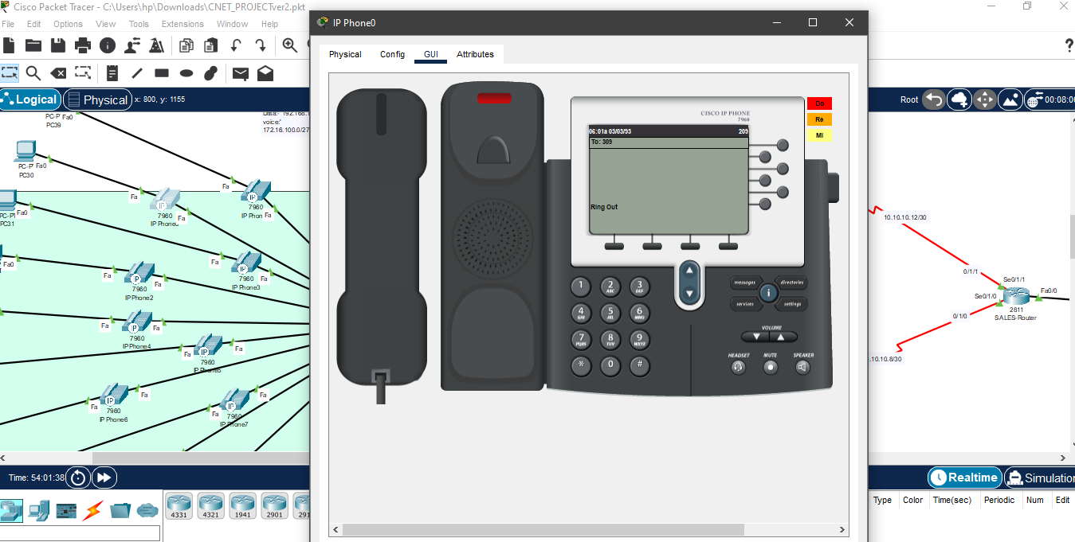

**Conclusion:**

Implemented Cisco 2811 routers and Cisco 2960 switches, configured VLANs, OSPF routing, SSH access, and VoIP dial-peering for inter-department communication, verified functionality within the Finance department,HR department ,SALES department and ICT department.